**UNEARTHING THE ENVIRONMENTAL IMPACT OF HUMAN ACTIVITY: A GLOBAL CO2 EMISSION ANALYSIS**

**SUBMITTED BY:**

**SARUMATHI.S**

**AYEESHA SHAHANI.B**

**JANARTHINIKA.T**

**MAHESWARI.S**

**SOWMYA.K**

**VINITHA.V**

**1. INTRODUCTION:**

* **Overview:**

Global warming is one of the biggest challenges currently being faced by the human race, although correlation is not causation, a likely cause of global warming is due to increased atmospheric carbon dioxide from human activities. **CO2 Emission** refers to the Carbon Dioxide emitted throughout the world.

For this analysis we will be focusing on CO2 Emissions and its effect on the world we live in as well as some key factors and stats that may play a role in the emission of CO2 globally. Fossil fuel use is the primary source of CO2. The data throws light onto how much fossil fuels are burnt, per year per nation, which amounts to an increase in CO2 every year. This will help researchers and environment experts to predict global warming. So countries should set a goal to decrease this amount yearly.

Analysing Global Co2 Emission across countries from 1975 to 2020. This dataset contains a record of Co2

Emission by each Country and Region of Earth, here we are going to analyse and visualise Country wise.

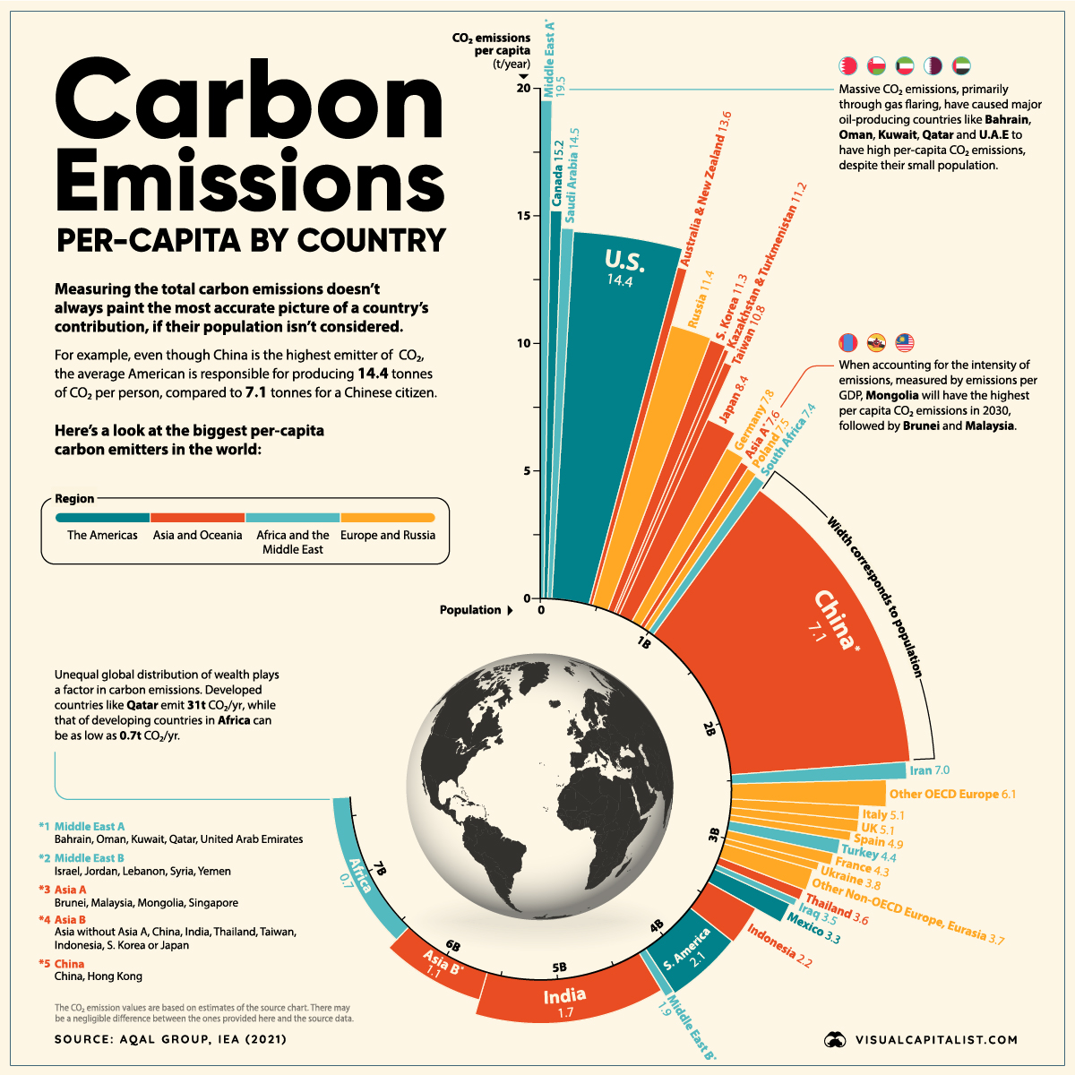

Region wise and Overall Co2 Emission on Earth.

* **PURPOSE:**

The carbon (and oxygen) in CO2 can be used as an alternative to fossil fuels in the production of chemicals, including plastics, fibres and synthetic rubber. As with CO2-derived fuels, converting CO2 to methanol and methane is the most technologically

mature pathway. The methanol can be subsequently converted into other carbon-containing high-value chemical intermediates such as olefins, which are used to manufacture plastics, and aromatics, which are used in a range of sectors including health and hygiene, food production and processing.

A special group of chemicals, polymers, are used in the production of plastics, foams and resins. The carbon in CO2 can be used in polymer production by replacing part of the fossil fuel-based raw material in the manufacturing process. Unlike the conversion of CO2 to fuels and chemical intermediates, polymer processing with CO2 requires little energy input, because CO2 is converted into a molecule with an even lower energy state (carbonate). A number of companies are currently operating polymer plants using CO2 as a raw material.

**2.PROBLEM DEFINITION & DESIGN THINKING:**

* **EMPATHY MAP:**

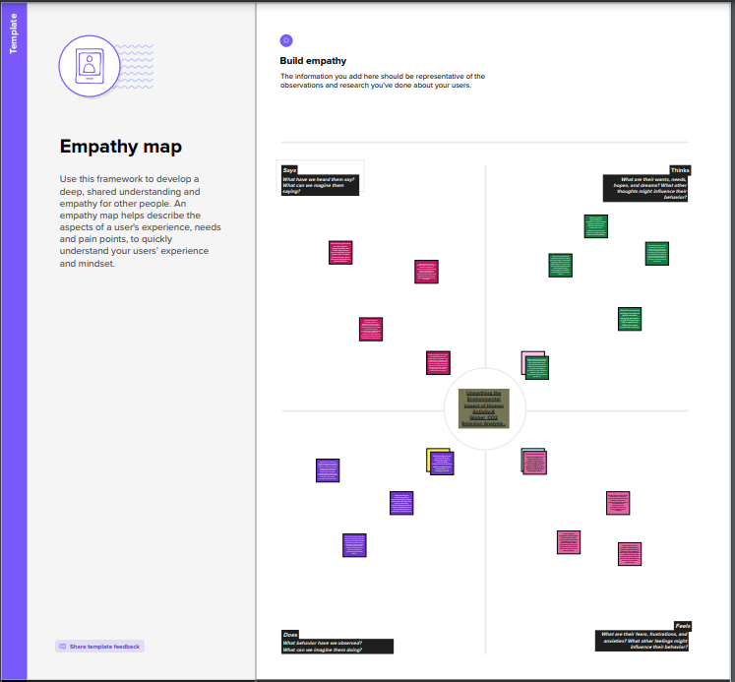

* **IDEATION & BRAINSTORMING MAP:**

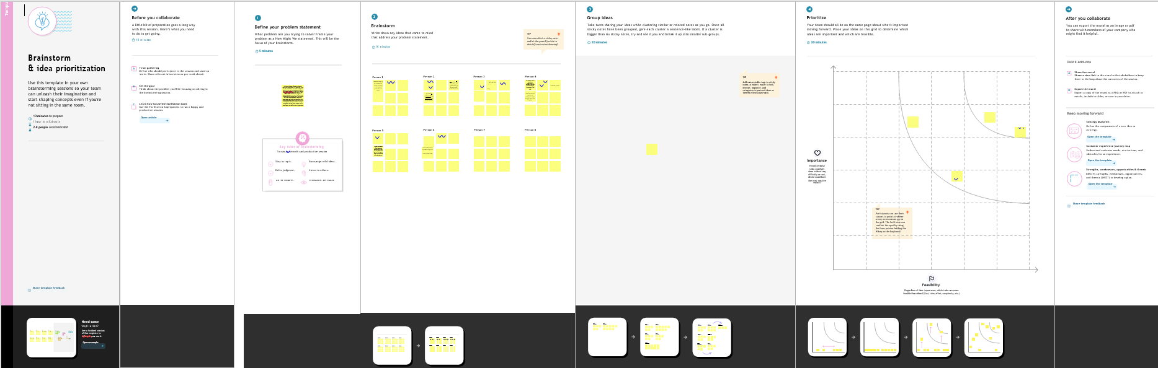

**3.RESULT:**

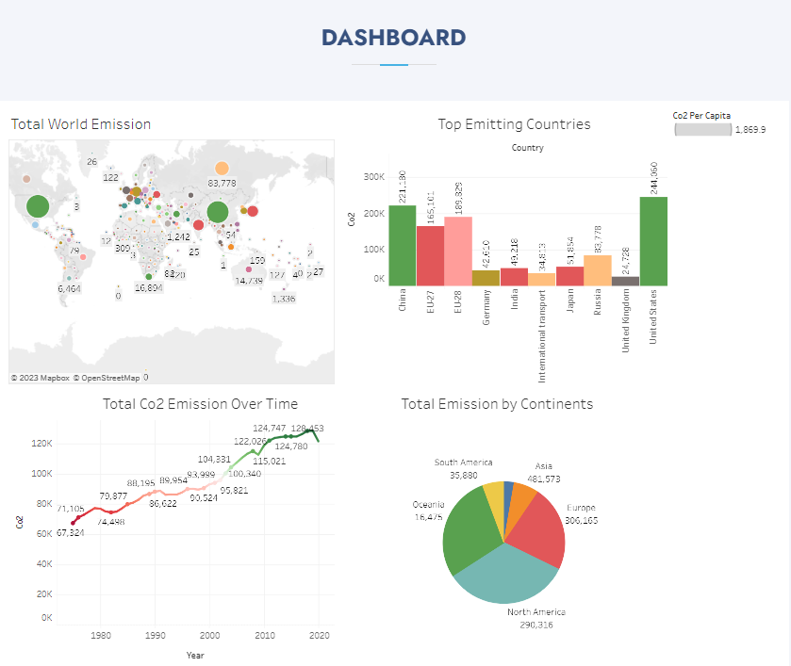

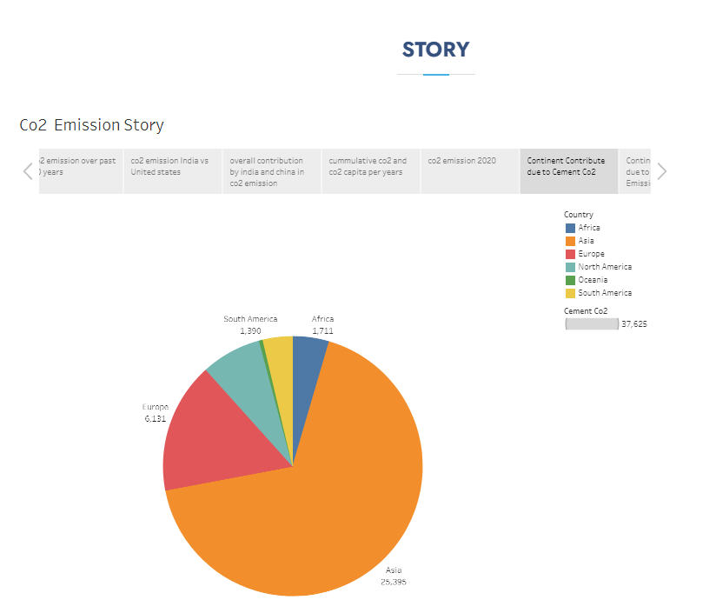

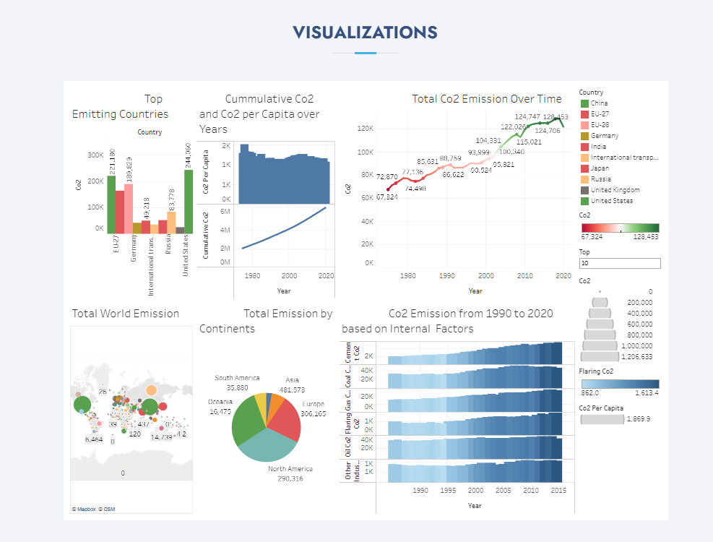

**4. ADVANTAGES & DISADVANTAGES:**

* **ADVANTAGES**:

Technology more than other alternatives can easily retrofit into existing plants; High CO2concentration enhance sorption efficiency; fully developed technology, commercially deployed at the required scale in some industrial sectors; opportunity for retrofit to existing plant

Very high CO2 concentration that enhances absorption efficiency; mature air separation technologies available; reduced volume of gas to be treated, hence required smaller boiler and other equipment; CO2 combustion product, which remains unmixed with N2, thus avoiding energy intensive air separation.

* **DISADVANTAGES:**

Low CO2 concentration affects the capture efficiency.

Temperature associated heat transfer problem and efficiency decay issues associated with the use of hydrogen-rich gas turbine fuel; high parasitic power requirement for sorbent regeneration; inadequate experience due to few gasification plants currently operated in the market; high capital and operating costs for current sorption systems; High efficiency drop and energy penalty; cryogenic O2 production is costly; corrosion problem may arise.

Process is still under development and inadequate large scale operation experience.

**5. APPLICATIONS:**

1. **CO2-derived fuels:**

The carbon in CO2 can be used to produce fuels that are in use today, including methane, methanol, gasoline and aviation fuels. The process involves using the CO2 in combination with hydrogen, which is highly energy-intensive to produce, and results in a carbon-containing fuel that is easier to handle and use than pure hydrogen (Figure 5). Low-carbon hydrogen can be produced from fossil fuels when combined with CCS, or through electrolysis of water using low-carbon electricity

1. **CO2-derived chemicals:**

The carbon (and oxygen) in CO2 can be used as an alternative to fossil fuels in the production of chemicals, including plastics, fibres and synthetic rubber. As with CO2-derived fuels, converting CO2 to methanol and methane is the most technologically mature pathway. The methanol can be subsequently converted into other carbon-containing high-value chemical

intermediates such as olefins, which are used to manufacture plastics, and aromatics, which are used in a range of sectors including health and hygiene, food production and processing.

1. **Building materials from minerals and CO2:**

CO2 can be used in the production of building materials to replace water in concrete, called CO2 curing, or as a raw material in its constituents (cement and construction aggregates). These applications involve the reaction of CO2 with calcium or magnesium to form low-energy carbonate molecules, the form of carbon that makes up concrete (Figure 7). CO2-cured concrete is one of the most mature and promising applications of CO2 use, while the integration of CO2 in the production of cement itself is at an earlier stage of development.

1. **Building materials from waste and CO2:**

Construction aggregates (small particulates used in building materials) can be produced by reacting CO2 with waste materials from power plants or industrial processes. Among these are iron slag and coal fly ash, which would otherwise be stockpiled or stored in landfill.

Producing building materials from waste and CO2 can be competitive as it offsets the cost associated with conventional waste disposal.

1. **CROP YIELD BOOSTING WITH CO2:**

CO2 can be used to enhance yields of biological processes, such as algae production and crop cultivation in greenhouses. The application of CO2 with low-temperature heat in industrial greenhouses is the most mature yield-boosting application today, and can increase yields by 25% to 30%. The clear leader in the use of CO2 in greenhouses is the Netherlands, with an estimated annual consumption between 5 and 6.3 MtCO2. Of this amount, approximately 500 ktCO2 per year comes from external sources, mainly industrial plants, with the balance taken from on-site gas-fired boilers or co-generation systems. The replacement of these on-site systems with other industrial CO2 sources or with CO2 captured directly from the atmosphere could deliver climate benefits.

1. **CONCLUSION:**

The rising level of atmospheric CO2 could be the one global natural resource that is progressively increasing food production and total biological output, in a world of otherwise diminishing natural resources of land, water, energy, minerals, and fertilizer. It is a means of inadvertently increasing the productivity of farming systems and other photo synthetically active ecosystems. The effects know no boundaries and both developing and developed countries are, and will be, sharing equally, for "the rising level of atmospheric CO2 is a universally free premium, gaining in magnitude with time, on which we all can reckon for the foreseeable future"

The relationship described above by where data pertaining to atmospheric CO2 emissions, food production, and human population are plotted. Standardized to a value of unity in 1961, each of these datasets has experienced rapid and interlinked growth over the past five decades. Rising global population has led to rising CO2 emissions and rising CO2 emissions have benefited food production.

The very real positive externality of inadvertent atmospheric CO2 enrichment must be considered in all studies examining the SCC; and its observationally-deduced effects must be given premier weighting over the speculative negative externalities presumed to occur in computer model projections of global warming. Until that time, little if any weight should be placed on current SCC calculations.

1. **FUTURE SCOPE:**

In the [*Annual Energy Outlook 2022*](https://www.eia.gov/outlooks/aeo/) (AEO2022) Reference case, which assumes no changes to current laws or regulations, the U.S. Energy Information Administration (EIA) projects that U.S. energy-related carbon dioxide (CO**2**) emissions will fall to 4.5 billion metric tons in 2037, or 6% below the energy-related CO**2** emissions in 2021, before rising to 4.7 billion metric tons in 2050, or 2% below 2021 levels. Projected emissions decline from 2022 to 2037 primarily as a result of decreasing carbon intensity (CO**2** per unit of energy consumed) in the electric power sector. The rise in emissions from 2037 to 2050 is primarily due to increasing consumption. In the AEO2022 Reference

case, U.S. energy consumption grows from 2021 through 2050 because of population growth of 0.4% per year and real economic growth of 2.2% per year. Over the projection period, increasing CO**2** emissions from natural gas and petroleum consumption growth will offset declines in CO**2** emissions from coal consumption.

## World CO2 emissions are projected to increase

EIA’s [*International Energy Outlook 2021*](https://www.eia.gov/outlooks/ieo) (IEO2021) Reference case projects that if current policy and technology trends continue, global energy consumption and energy-related CO**2** emissions will increase from 2020 through 2050 as a result of population and economic growth. However, projected future growth in energy-related CO**2** emissions is not evenly distributed across the world, and the majority of the projected future growth in energy-related CO**2** emissions is among the group of countries outside the [Organization for Economic Cooperation and Development (OECD)](http://www.oecd.org/).

1. **APPENDIX:**

* **SOURCE CODE:**

<!DOCTYPE html>

<html lang="en">

<head>

<meta charset="utf-8">

<meta content="width=device-width, initial-scale=1.0" name="viewport">

<title>Co2 Emission - Index</title>

<meta content="" name="description">

<meta content="" name="keywords">

<!-- Favicons -->

<link href="assets/img/favicon.png" rel="icon">

<link href="assets/img/apple-touch-icon.png" rel="apple-touch-icon">

<!-- Google Fonts -->

<link href="[https://fonts.googleapis.com/css?family=Open+Sans:300,300i,400,400i,600,600i,700,700i|Jost:300,300i,400,400i,500,500i,600,600i,700,700i|Poppins:300,300i,400,400i,500,500i,600,600i,700,700i](https://fonts.googleapis.com/css?family=Open+Sans:300,300i,400,400i,600,600i,700,700i%7CJost:300,300i,400,400i,500,500i,600,600i,700,700i%7CPoppins:300,300i,400,400i,500,500i,600,600i,700,700i)" rel="stylesheet">

<!-- Vendor CSS Files -->

<link href="assets/vendor/aos/aos.css" rel="stylesheet">

<link href="assets/vendor/bootstrap/css/bootstrap.min.css" rel="stylesheet">

<link href="assets/vendor/bootstrap-icons/bootstrap-icons.css" rel="stylesheet">

<link href="assets/vendor/boxicons/css/boxicons.min.css" rel="stylesheet">

<link href="assets/vendor/glightbox/css/glightbox.min.css" rel="stylesheet">

<link href="assets/vendor/remixicon/remixicon.css" rel="stylesheet">

<link href="assets/vendor/swiper/swiper-bundle.min.css" rel="stylesheet">

<!-- Template Main CSS File -->

<link href="assets/css/style.css" rel="stylesheet">

<!-- =======================================================

* Template Name: Arsha

* Updated: Mar 10 2023 with Bootstrap v5.2.3

* Template URL: <https://bootstrapmade.com/arsha-free-bootstrap-html-template-corporate/>

* Author: BootstrapMade.com

* License: <https://bootstrapmade.com/license/>

======================================================== -->

</head>

<body>

<!-- ======= Header ======= -->

<header id="header" class="fixed-top ">

<div class="container d-flex align-items-center">

<h1 class="logo me-auto"><a href="index.html">Co2</a></h1>

<!-- Uncomment below if you prefer to use an image logo -->

<!-- <a href="index.html" class="logo me-auto"><img src="assets/img/logo.png" alt="" class="img-fluid"></a>-->

<nav id="navbar" class="navbar">

<ul>

<li><a class="nav-link scrollto active" href="#hero">Home</a></li>

<li><a class="nav-link scrollto" href="#about">About</a></li>

<li><a class="nav-link scrollto" href="#services">Dashboard</a></li>

<li><a class="nav-link   scrollto" href="#portfolio">Story

</a></li>

<li><a class="nav-link scrollto" href="#team">Team</a></li>

<li class="dropdown"><a href="#"><span>Drop Down</span> <i class="bi bi-chevron-down"></i></a>

<ul>

<li><a href="#">Drop Down 1</a></li>

<li class="dropdown"><a href="#"><span>Deep Drop Down</span> <i class="bi bi-chevron-right"></i></a>

<ul>

<li><a href="#">Deep Drop Down 1</a></li>

<li><a href="#">Deep Drop Down 2</a></li>

<li><a href="#">Deep Drop Down 3</a></li>

<li><a href="#">Deep Drop Down 4</a></li>

<li><a href="#">Deep Drop Down 5</a></li>

</ul>

</li>

<li><a href="#">Drop Down 2</a></li>

<li><a href="#">Drop Down 3</a></li>

<li><a href="#">Drop Down 4</a></li>

</ul>

</li>

<li><a class="nav-link scrollto" href="#contact">Contact</a></li>

<li><a class="getstarted scrollto" href="#about">Get Started</a></li>

</ul>

<i class="bi bi-list mobile-nav-toggle"></i>

</nav><!-- .navbar -->

</div>

</header><!-- End Header -->

<!-- ======= Hero Section ======= -->

<section id="hero" class="d-flex align-items-center">

<div class="container">

<div class="row">

<div class="col-lg-6 d-flex flex-column justify-content-center pt-4 pt-lg-0 order-2 order-lg-1" data-aos="fade-up" data-aos-delay="200">

<h1>Global Co2 Emission Analysis</h1>

<h2>We are team of talented designers making websites with Bootstrap</h2>

<div class="d-flex justify-content-center justify-content-lg-start">

<a href="#about" class="btn-get-started scrollto">Get Started</a>

<a href="<https://www.youtube.com/watch?v=jDDaplaOz7Q>" class="glightbox btn-watch-video"><i class="bi bi-play-circle"></i><span>Watch Video</span></a>

</div>

</div>

<div class="col-lg-6 order-1 order-lg-2 hero-img" data-aos="zoom-in" data-aos-delay="200">

<img src="assets/img/hero-img.png" class="img-fluid animated" alt="">

</div>

</div>

</div>

</section><!-- End Hero -->

<main id="main">

<!-- ======= Clients Section ======= -->

<section id="clients" class="clients section-bg">

<div class="container">

<div class="row" data-aos="zoom-in">

<div class="col-lg-2 col-md-4 col-6 d-flex align-items-center justify-content-center">

<img src="assets/img/clients/client-1.png" class="img-fluid" alt="">

</div>

<div class="col-lg-2 col-md-4 col-6 d-flex align-items-center justify-content-center">

<img src="assets/img/clients/client-2.png" class="img-fluid" alt="">

</div>

<div class="col-lg-2 col-md-4 col-6 d-flex align-items-center justify-content-center">

<img src="assets/img/clients/client-3.png" class="img-fluid" alt="">

</div>

<div class="col-lg-2 col-md-4 col-6 d-flex align-items-center justify-content-center">

<img src="assets/img/clients/client-4.png" class="img-fluid" alt="">

</div>

<div class="col-lg-2 col-md-4 col-6 d-flex align-items-center justify-content-center">

<img src="assets/img/clients/client-5.png" class="img-fluid" alt="">

</div>

<div class="col-lg-2 col-md-4 col-6 d-flex align-items-center justify-content-center">

<img src="assets/img/clients/client-6.png" class="img-fluid" alt="">

</div>

</div>

</div>

</section><!-- End Cliens Section -->

<!-- ======= About Us Section ======= -->

<section id="about" class="about">

<div class="container" data-aos="fade-up">

<div class="section-title">

<h2>About Us</h2>

</div>

<div class="row content">

<div class="col-lg-6">

<p>

Carbon dioxide emissions are those stemming from the burning of fossil fuels and the manufacturer of cement. They include carbon dioxide produced during consumption of solid,liquid and gas fuels and gas flaring.

</p>

<ul>

</ul>

</div>

<div class="col-lg-6 pt-4 pt-lg-0">

<p>

Global carbon dioxide(CO2)emissions from fossil fuels and industry have increased considerably since 2000, and in 2019 reached a record high of 36. 7 billion metric tons of CO2. In 2020, the COVID-19 pandemic caused global CO2 emissions to plummet five percent to 34.81 billion metric tons.

</p>

<a href="#" class="btn-learn-more">Learn More</a>

</div>

</div>

</div>

</section><!-- End About Us Section -->

<!-- ======= Why Us Section ======= -->

<section id="why-us" class="why-us section-bg">

<div class="container-fluid" data-aos="fade-up">

<div class="row">

<div class="col-lg-7 d-flex flex-column justify-content-center align-items-stretch  order-2 order-lg-1">

<div class="content">

<h3>Eum ipsam laborum deleniti <strong>velit pariatur architecto aut nihil</strong></h3>

<p>

Lorem ipsum dolor sit amet, consectetur adipiscing elit, sed do eiusmod tempor incididunt ut labore et dolore magna aliqua. Duis aute irure dolor in reprehenderit

</p>

</div>

<div class="accordion-list">

<ul>

<li>

<a data-bs-toggle="collapse" class="collapse" data-bs-target="#accordion-list-1"><span>01</span> Non consectetur a erat nam at lectus urna duis? <i class="bx bx-chevron-down icon-show"></i><i class="bx bx-chevron-up icon-close"></i></a>

<div id="accordion-list-1" class="collapse show" data-bs-parent=".accordion-list">

<p>

Feugiat pretium nibh ipsum consequat. Tempus iaculis urna id volutpat lacus laoreet non curabitur gravida. Venenatis lectus magna fringilla urna porttitor rhoncus dolor purus non.

</p>

</div>

</li>

<li>

<a data-bs-toggle="collapse" data-bs-target="#accordion-list-2" class="collapsed"><span>02</span> Feugiat scelerisque varius morbi enim nunc? <i class="bx bx-chevron-down icon-show"></i><i class="bx bx-chevron-up icon-close"></i></a>

<div id="accordion-list-2" class="collapse" data-bs-parent=".accordion-list">

<p>

Dolor sit amet consectetur adipiscing elit pellentesque habitant morbi. Id interdum velit laoreet id donec ultrices. Fringilla phasellus faucibus scelerisque eleifend donec pretium. Est pellentesque elit ullamcorper dignissim. Mauris ultrices eros in cursus turpis massa tincidunt dui.

</p>

</div>

</li>

<li>

<a data-bs-toggle="collapse" data-bs-target="#accordion-list-3" class="collapsed"><span>03</span> Dolor sit amet consectetur adipiscing elit? <i class="bx bx-chevron-down icon-show"></i><i class="bx bx-chevron-up icon-close"></i></a>

<div id="accordion-list-3" class="collapse" data-bs-parent=".accordion-list">

<p>

Eleifend mi in nulla posuere sollicitudin aliquam ultrices sagittis orci. Faucibus pulvinar elementum integer enim. Sem nulla pharetra diam sit amet nisl suscipit. Rutrum tellus pellentesque eu tincidunt. Lectus urna duis convallis convallis tellus. Urna molestie at elementum eu facilisis sed odio morbi quis

</p>

</div>

</li>

</ul>

</div>

</div>

<div class="col-lg-5 align-items-stretch order-1 order-lg-2 img" style='background-image: url("assets/img/why-us.png");' data-aos="zoom-in" data-aos-delay="150">&nbsp;</div>

</div>

</div>

</section><!-- End Why Us Section -->

<!-- ======= Skills Section ======= -->

<section id="skills" class="skills">

<div class="container" data-aos="fade-up">

<div class="row">

<div class="col-lg-6 d-flex align-items-center" data-aos="fade-right" data-aos-delay="100">

<img src="assets/img/skills.png" class="img-fluid" alt="">

</div>

<div class="col-lg-6 pt-4 pt-lg-0 content" data-aos="fade-left" data-aos-delay="100">

<h3>Voluptatem dignissimos provident quasi corporis voluptates</h3>

<p class="fst-italic">

Lorem ipsum dolor sit amet, consectetur adipiscing elit, sed do eiusmod tempor incididunt ut labore et dolore

magna aliqua.

</p>

<div class="skills-content">

<div class="progress">

<span class="skill">HTML <i class="val">100%</i></span>

<div class="progress-bar-wrap">

<div class="progress-bar" role="progressbar" aria-valuenow="100" aria-valuemin="0" aria-valuemax="100"></div>

</div>

</div>

<div class="progress">

<span class="skill">CSS <i class="val">90%</i></span>

<div class="progress-bar-wrap">

<div class="progress-bar" role="progressbar" aria-valuenow="90" aria-valuemin="0" aria-valuemax="100"></div>

</div>

</div>

<div class="progress">

<span class="skill">JavaScript <i class="val">75%</i></span>

<div class="progress-bar-wrap">

<div class="progress-bar" role="progressbar" aria-valuenow="75" aria-valuemin="0" aria-valuemax="100"></div>

</div>

</div>

<div class="progress">

<span class="skill">Photoshop <i class="val">55%</i></span>

<div class="progress-bar-wrap">

<div class="progress-bar" role="progressbar" aria-valuenow="55" aria-valuemin="0" aria-valuemax="100"></div>

</div>

</div>

</div>

</div>

</div>

</div>

</section><!-- End Skills Section -->

<!-- ======= Services Section ======= -->

<section id="services" class="services section-bg">

<div class="container" data-aos="fade-up">

<div class="section-title">

<h2>Dashboard</h2>

</div>

<div class='tableauPlaceholder' id='viz1681190503345' style='position: relative'><noscript><a href='#'><img alt='Dashboard 1 ' src='https:&#47;&#47;[public.tableau.com](http://public.tableau.com/)&#47;static&#47;images&#47;da&#47;dashboard1_16811897445690&#47;Dashboard1&#47;1_rss.png' style='border: none' /></a></noscript><object class='tableauViz'  style='display:none;'><param name='host_url' value='https%3A%2F%[2Fpublic.tableau.com](http://2fpublic.tableau.com/)%2F' /> <param name='embed_code_version' value='3' /> <param name='site_root' value='' /><param name='name' value='dashboard1_16811897445690&#47;Dashboard1' /><param name='tabs' value='no' /><param name='toolbar' value='yes' /><param name='static_image' value='https:&#47;&#47;[public.tableau.com](http://public.tableau.com/)&#47;static&#47;images&#47;da&#47;dashboard1_16811897445690&#47;Dashboard1&#47;1.png' /> <param name='animate_transition' value='yes' /><param name='display_static_image' value='yes' /><param name='display_spinner' value='yes' /><param name='display_overlay' value='yes' /><param name='display_count' value='yes' /><param name='language' value='en-US' /><param name='filter' value='publish=yes' /></object></div>                <script type='text/javascript'>                    var divElement = document.getElementById('viz1681190503345');                    var vizElement = divElement.getElementsByTagName('object')[0];                    if ( divElement.offsetWidth > 800 ) { vizElement.style.width='100%';vizElement.style.height=(divElement.offsetWidth*0.75)+'px';} else if ( divElement.offsetWidth > 500 ) { vizElement.style.width='100%';vizElement.style.height=(divElement.offsetWidth*0.75)+'px';} else { vizElement.style.width='100%';vizElement.style.height='1277px';}                     var scriptElement = document.createElement('script');                    scriptElement.src = '<https://public.tableau.com/javascripts/api/viz_v1.js>';                    vizElement.parentNode.insertBefore(scriptElement, vizElement);                </script>

</div>

</section>

<!-- End Cta Section -->

<!-- ======= Portfolio Section ======= -->

<section id="portfolio" class="portfolio">

<div class="container" data-aos="fade-up">

<div class="section-title">

<h2>story</h2>

</div>

<div class='tableauPlaceholder' id='viz1681190627804' style='position: relative'><noscript><a href='#'><img alt='Co2  Emission Story ' src='https:&#47;&#47;[public.tableau.com](http://public.tableau.com/)&#47;static&#47;images&#47;Co&#47;Co2story_16811190960490&#47;Story1&#47;1_rss.png' style='border: none' /></a></noscript><object class='tableauViz'  style='display:none;'><param name='host_url' value='https%3A%2F%[2Fpublic.tableau.com](http://2fpublic.tableau.com/)%2F' /> <param name='embed_code_version' value='3' /> <param name='site_root' value='' /><param name='name' value='Co2story_16811190960490&#47;Story1' /><param name='tabs' value='no' /><param name='toolbar' value='yes' /><param name='static_image' value='https:&#47;&#47;[public.tableau.com](http://public.tableau.com/)&#47;static&#47;images&#47;Co&#47;Co2story_16811190960490&#47;Story1&#47;1.png' /> <param name='animate_transition' value='yes' /><param name='display_static_image' value='yes' /><param name='display_spinner' value='yes' /><param name='display_overlay' value='yes' /><param name='display_count' value='yes' /><param name='language' value='en-US' /></object></div>                <script type='text/javascript'>                    var divElement = document.getElementById('viz1681190627804');                    var vizElement = divElement.getElementsByTagName('object')[0];                    vizElement.style.width='1016px';vizElement.style.height='991px';                    var scriptElement = document.createElement('script');                    scriptElement.src = '<https://public.tableau.com/javascripts/api/viz_v1.js>';                    vizElement.parentNode.insertBefore(scriptElement, vizElement);                </script>

</section>

<!-- End Portfolio Section -->

<!-- ======= Visulizations Section ======= -->

<section id="team" class="team section-bg">

<div class="container" data-aos="fade-up">

<div class="section-title">

<h2>Visualizations</h2>

</div>

<div class='tableauPlaceholder' id='viz1681198412334' style='position: relative'><noscript><a href='#'><img alt='Visualizations' src='https:&#47;&#47;[public.tableau.com](http://public.tableau.com/)&#47;static&#47;images&#47;vi&#47;visualization_16811980502610&#47;Dashboard4&#47;1_rss.png' style='border: none' /></a></noscript><object class='tableauViz'  style='display:none;'><param name='host_url' value='https%3A%2F%[2Fpublic.tableau.com](http://2fpublic.tableau.com/)%2F' /> <param name='embed_code_version' value='3' /> <param name='site_root' value='' /><param name='name' value='visualization_16811980502610&#47;Dashboard4' /><param name='tabs' value='no' /><param name='toolbar' value='yes' /><param name='static_image' value='https:&#47;&#47;[public.tableau.com](http://public.tableau.com/)&#47;static&#47;images&#47;vi&#47;visualization_16811980502610&#47;Dashboard4&#47;1.png' /> <param name='animate_transition' value='yes' /><param name='display_static_image' value='yes' /><param name='display_spinner' value='yes' /><param name='display_overlay' value='yes' /><param name='display_count' value='yes' /><param name='language' value='en-US' /><param name='filter' value='publish=yes' /></object></div>                <script type='text/javascript'>                    var divElement = document.getElementById('viz1681198412334');                    var vizElement = divElement.getElementsByTagName('object')[0];                    if ( divElement.offsetWidth > 800 ) { vizElement.style.width='100%';vizElement.style.height=(divElement.offsetWidth*0.75)+'px';} else if ( divElement.offsetWidth > 500 ) { vizElement.style.width='100%';vizElement.style.height=(divElement.offsetWidth*0.75)+'px';} else { vizElement.style.width='100%';vizElement.style.height='2177px';}                     var scriptElement = document.createElement('script');                    scriptElement.src = '<https://public.tableau.com/javascripts/api/viz_v1.js>';                    vizElement.parentNode.insertBefore(scriptElement, vizElement);                </script>

</section>

<!-- End Visualizations Section -->

<!-- ======= Pricing Section ======= -->

<section id="pricing" class="pricing">

<div class="container" data-aos="fade-up">

<div class="section-title">

<h2>Pricing</h2>

<p>Magnam dolores commodi suscipit. Necessitatibus eius consequatur ex aliquid fuga eum quidem. Sit sint consectetur velit. Quisquam quos quisquam cupiditate. Et nemo qui impedit suscipit alias ea. Quia fugiat sit in iste officiis commodi quidem hic quas.</p>

</div>

<div class="row">

<div class="col-lg-4" data-aos="fade-up" data-aos-delay="100">

<div class="box">

<h3>Free Plan</h3>

<h4><sup>$</sup>0<span>per month</span></h4>

<ul>

<li><i class="bx bx-check"></i> Quam adipiscing vitae proin</li>

<li><i class="bx bx-check"></i> Nec feugiat nisl pretium</li>

<li><i class="bx bx-check"></i> Nulla at volutpat diam uteera</li>

<li class="na"><i class="bx bx-x"></i> <span>Pharetra massa massa ultricies</span></li>

<li class="na"><i class="bx bx-x"></i> <span>Massa ultricies mi quis hendrerit</span></li>

</ul>

<a href="#" class="buy-btn">Get Started</a>

</div>

</div>

<div class="col-lg-4 mt-4 mt-lg-0" data-aos="fade-up" data-aos-delay="200">

<div class="box featured">

<h3>Business Plan</h3>

<h4><sup>$</sup>29<span>per month</span></h4>

<ul>

<li><i class="bx bx-check"></i> Quam adipiscing vitae proin</li>

<li><i class="bx bx-check"></i> Nec feugiat nisl pretium</li>

<li><i class="bx bx-check"></i> Nulla at volutpat diam uteera</li>

<li><i class="bx bx-check"></i> Pharetra massa massa ultricies</li>

<li><i class="bx bx-check"></i> Massa ultricies mi quis hendrerit</li>

</ul>

<a href="#" class="buy-btn">Get Started</a>

</div>

</div>

<div class="col-lg-4 mt-4 mt-lg-0" data-aos="fade-up" data-aos-delay="300">

<div class="box">

<h3>Developer Plan</h3>

<h4><sup>$</sup>49<span>per month</span></h4>

<ul>

<li><i class="bx bx-check"></i> Quam adipiscing vitae proin</li>

<li><i class="bx bx-check"></i> Nec feugiat nisl pretium</li>

<li><i class="bx bx-check"></i> Nulla at volutpat diam uteera</li>

<li><i class="bx bx-check"></i> Pharetra massa massa ultricies</li>

<li><i class="bx bx-check"></i> Massa ultricies mi quis hendrerit</li>

</ul>

<a href="#" class="buy-btn">Get Started</a>

</div>

</div>

</div>

</div>

</section><!-- End Pricing Section -->

<!-- ======= Frequently Asked Questions Section ======= -->

<section id="faq" class="faq section-bg">

<div class="container" data-aos="fade-up">

<div class="section-title">

<h2>Frequently Asked Questions</h2>

<p>Magnam dolores commodi suscipit. Necessitatibus eius consequatur ex aliquid fuga eum quidem. Sit sint consectetur velit. Quisquam quos quisquam cupiditate. Et nemo qui impedit suscipit alias ea. Quia fugiat sit in iste officiis commodi quidem hic quas.</p>

</div>

<div class="faq-list">

<ul>

<li data-aos="fade-up" data-aos-delay="100">

<i class="bx bx-help-circle icon-help"></i> <a data-bs-toggle="collapse" class="collapse" data-bs-target="#faq-list-1">Non consectetur a erat nam at lectus urna duis? <i class="bx bx-chevron-down icon-show"></i><i class="bx bx-chevron-up icon-close"></i></a>

<div id="faq-list-1" class="collapse show" data-bs-parent=".faq-list">

<p>

Feugiat pretium nibh ipsum consequat. Tempus iaculis urna id volutpat lacus laoreet non curabitur gravida. Venenatis lectus magna fringilla urna porttitor rhoncus dolor purus non.

</p>

</div>

</li>

<li data-aos="fade-up" data-aos-delay="200">

<i class="bx bx-help-circle icon-help"></i> <a data-bs-toggle="collapse" data-bs-target="#faq-list-2" class="collapsed">Feugiat scelerisque varius morbi enim nunc? <i class="bx bx-chevron-down icon-show"></i><i class="bx bx-chevron-up icon-close"></i></a>

<div id="faq-list-2" class="collapse" data-bs-parent=".faq-list">

<p>

Dolor sit amet consectetur adipiscing elit pellentesque habitant morbi. Id interdum velit laoreet id donec ultrices. Fringilla phasellus faucibus scelerisque eleifend donec pretium. Est pellentesque elit ullamcorper dignissim. Mauris ultrices eros in cursus turpis massa tincidunt dui.

</p>

</div>

</li>

<li data-aos="fade-up" data-aos-delay="300">

<i class="bx bx-help-circle icon-help"></i> <a data-bs-toggle="collapse" data-bs-target="#faq-list-3" class="collapsed">Dolor sit amet consectetur adipiscing elit? <i class="bx bx-chevron-down icon-show"></i><i class="bx bx-chevron-up icon-close"></i></a>

<div id="faq-list-3" class="collapse" data-bs-parent=".faq-list">

<p>

Eleifend mi in nulla posuere sollicitudin aliquam ultrices sagittis orci. Faucibus pulvinar elementum integer enim. Sem nulla pharetra diam sit amet nisl suscipit. Rutrum tellus pellentesque eu tincidunt. Lectus urna duis convallis convallis tellus. Urna molestie at elementum eu facilisis sed odio morbi quis

</p>

</div>

</li>

<li data-aos="fade-up" data-aos-delay="400">

<i class="bx bx-help-circle icon-help"></i> <a data-bs-toggle="collapse" data-bs-target="#faq-list-4" class="collapsed">Tempus quam pellentesque nec nam aliquam sem et tortor consequat? <i class="bx bx-chevron-down icon-show"></i><i class="bx bx-chevron-up icon-close"></i></a>

<div id="faq-list-4" class="collapse" data-bs-parent=".faq-list">

<p>

Molestie a iaculis at erat pellentesque adipiscing commodo. Dignissim suspendisse in est ante in. Nunc vel risus commodo viverra maecenas accumsan. Sit amet nisl suscipit adipiscing bibendum est. Purus gravida quis blandit turpis cursus in.

</p>

</div>

</li>

<li data-aos="fade-up" data-aos-delay="500">

<i class="bx bx-help-circle icon-help"></i> <a data-bs-toggle="collapse" data-bs-target="#faq-list-5" class="collapsed">Tortor vitae purus faucibus ornare. Varius vel pharetra vel turpis nunc eget lorem dolor? <i class="bx bx-chevron-down icon-show"></i><i class="bx bx-chevron-up icon-close"></i></a>

<div id="faq-list-5" class="collapse" data-bs-parent=".faq-list">

<p>

Laoreet sit amet cursus sit amet dictum sit amet justo. Mauris vitae ultricies leo integer malesuada nunc vel. Tincidunt eget nullam non nisi est sit amet. Turpis nunc eget lorem dolor sed. Ut venenatis tellus in metus vulputate eu scelerisque.

</p>

</div>

</li>

</ul>

</div>

</div>

</section><!-- End Frequently Asked Questions Section -->

<!-- ======= Contact Section ======= -->

<section id="contact" class="contact">

<div class="container" data-aos="fade-up">

<div class="section-title">

<h2>Contact</h2>

<p>Magnam dolores commodi suscipit. Necessitatibus eius consequatur ex aliquid fuga eum quidem. Sit sint consectetur velit. Quisquam quos quisquam cupiditate. Et nemo qui impedit suscipit alias ea. Quia fugiat sit in iste officiis commodi quidem hic quas.</p>

</div>

<div class="row">

<div class="col-lg-5 d-flex align-items-stretch">

<div class="info">

<div class="address">

<i class="bi bi-geo-alt"></i>

<h4>Location:</h4>

<p>A108 Adam Street, New York, NY 535022</p>

</div>

<div class="email">

<i class="bi bi-envelope"></i>

<h4>Email:</h4>

<p>[info@example.com](mailto:info@example.com)</p>

</div>

<div class="phone">

<i class="bi bi-phone"></i>

<h4>Call:</h4>

<p>+1 5589 55488 55s</p>

</div>

<iframe src="<https://www.google.com/maps/embed?pb=!1m14!1m8!1m3!1d12097.433213460943!2d-74.0062269!3d40.7101282!3m2!1i1024!2i768!4f13.1!3m3!1m2!1s0x0%3A0xb89d1fe6bc499443!2sDowntown+Conference+Center!5e0!3m2!1smk!2sbg!4v1539943755621>" frameborder="0" style="border:0; width: 100%; height: 290px;" allowfullscreen></iframe>

</div>

</div>

<div class="col-lg-7 mt-5 mt-lg-0 d-flex align-items-stretch">

<form action="forms/contact.php" method="post" role="form" class="php-email-form">

<div class="row">

<div class="form-group col-md-6">

<label for="name">Your Name</label>

<input type="text" name="name" class="form-control" id="name" required>

</div>

<div class="form-group col-md-6">

<label for="name">Your Email</label>

<input type="email" class="form-control" name="email" id="email" required>

</div>

</div>

<div class="form-group">

<label for="name">Subject</label>

<input type="text" class="form-control" name="subject" id="subject" required>

</div>

<div class="form-group">

<label for="name">Message</label>

<textarea class="form-control" name="message" rows="10" required></textarea>

</div>

<div class="my-3">

<div class="loading">Loading</div>

<div class="error-message"></div>

<div class="sent-message">Your message has been sent. Thank you!</div>

</div>

<div class="text-center"><button type="submit">Send Message</button></div>

</form>

</div>

</div>

</div>

</section><!-- End Contact Section -->

</main><!-- End #main -->

<!-- ======= Footer ======= -->

<footer id="footer">

<div class="footer-newsletter">

<div class="container">

<div class="row justify-content-center">

<div class="col-lg-6">

<h4>Join Our Newsletter</h4>

<p>Tamen quem nulla quae legam multos aute sint culpa legam noster magna</p>

<form action="" method="post">

<input type="email" name="email"><input type="submit" value="Subscribe">

</form>

</div>

</div>

</div>

</div>

<div class="footer-top">

<div class="container">

<div class="row">

<div class="col-lg-3 col-md-6 footer-contact">

<h3>Arsha</h3>

<p>

A108 Adam Street <br>

New York, NY 535022<br>

United States <br><br>

<strong>Phone:</strong> +1 5589 55488 55<br>

<strong>Email:</strong> [info@example.com](mailto:info@example.com)<br>

</p>

</div>

<div class="col-lg-3 col-md-6 footer-links">

<h4>Useful Links</h4>

<ul>

<li><i class="bx bx-chevron-right"></i> <a href="#">Home</a></li>

<li><i class="bx bx-chevron-right"></i> <a href="#">About us</a></li>

<li><i class="bx bx-chevron-right"></i> <a href="#">Services</a></li>

<li><i class="bx bx-chevron-right"></i> <a href="#">Terms of service</a></li>

<li><i class="bx bx-chevron-right"></i> <a href="#">Privacy policy</a></li>

</ul>

</div>

<div class="col-lg-3 col-md-6 footer-links">

<h4>Our Services</h4>

<ul>

<li><i class="bx bx-chevron-right"></i> <a href="#">Web Design</a></li>

<li><i class="bx bx-chevron-right"></i> <a href="#">Web Development</a></li>

<li><i class="bx bx-chevron-right"></i> <a href="#">Product Management</a></li>

<li><i class="bx bx-chevron-right"></i> <a href="#">Marketing</a></li>

<li><i class="bx bx-chevron-right"></i> <a href="#">Graphic Design</a></li>

</ul>

</div>

<div class="col-lg-3 col-md-6 footer-links">

<h4>Our Social Networks</h4>

<p>Cras fermentum odio eu feugiat lide par naso tierra videa magna derita valies</p>

<div class="social-links mt-3">

<a href="#" class="twitter"><i class="bx bxl-twitter"></i></a>

<a href="#" class="facebook"><i class="bx bxl-facebook"></i></a>

<a href="#" class="instagram"><i class="bx bxl-instagram"></i></a>

<a href="#" class="google-plus"><i class="bx bxl-skype"></i></a>

<a href="#" class="linkedin"><i class="bx bxl-linkedin"></i></a>

</div>

</div>

</div>

</div>

</div>

<div class="container footer-bottom clearfix">

<div class="copyright">

&copy; Copyright <strong><span>Arsha</span></strong>. All Rights Reserved

</div>

<div class="credits">

<!-- All the links in the footer should remain intact. -->

<!-- You can delete the links only if you purchased the pro version. -->

<!-- Licensing information: <https://bootstrapmade.com/license/> -->

<!-- Purchase the pro version with working PHP/AJAX contact form: <https://bootstrapmade.com/arsha-free-bootstrap-html-template-corporate/> -->

Designed by <a href="<https://bootstrapmade.com/>">BootstrapMade</a>

</div>

</div>

</footer><!-- End Footer -->

<div id="preloader"></div>

<a href="#" class="back-to-top d-flex align-items-center justify-content-center"><i class="bi bi-arrow-up-short"></i></a>

<!-- Vendor JS Files -->

<script src="assets/vendor/aos/aos.js"></script>

<script src="assets/vendor/bootstrap/js/bootstrap.bundle.min.js"></script>

<script src="assets/vendor/glightbox/js/glightbox.min.js"></script>

<script src="assets/vendor/isotope-layout/isotope.pkgd.min.js"></script>

<script src="assets/vendor/swiper/swiper-bundle.min.js"></script>

<script src="assets/vendor/waypoints/noframework.waypoints.js"></script>

<script src="assets/vendor/php-email-form/validate.js"></script>

<!-- Template Main JS File -->

<script src="assets/js/main.js"></script>

</body>

</html>